Testing Life Cycle
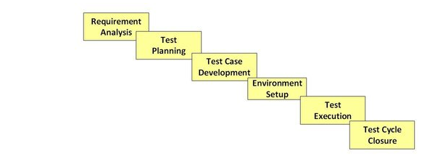
- Required Analysis:We will have FRD(Functional Required Document) and BRD(Business Required Document). BRD will have customers actual requirements and FRD will have functional requirements of each elements in the software product with clear explanation.QA`s should clearly go through the FRD to understand and if the they have any doubt,queries are goes to Business Analysts through HpQc.QA should get complete knowledge on requirement so that they can test against Actual requirement.
- Test Planning:Here QA discuss about days required to write test cases,the environments to test,what are the problems they may come across.
- Test Case Development:Once QA are clear about Requiremwnt documentation,QA start writing test cases (in Test planof HpQc) once they are done with wrtiting ,the test cases will be reviewed( by leads).If there are any modifications ,test cases should modified in a specific time and again get reviewed.
- Environment Setup:Testing Environment should be setup inorder to test the developed code.
- Test Execution:Once test cases and code is developed(test cases are copied from test plan to test lab in HpQc) test execution is done.If there are any bugs and defects are identified ,they are fixed by developers.Modified code is again tested to make sure code is working fine according to requirement document.
- Test Cycle Closure: It will move to production environment ,there UAT(User Acceptence Testing) will be done and it is different testing compare to testing done by testers. Leads will send their ProjectTest Summary report to the managers.

